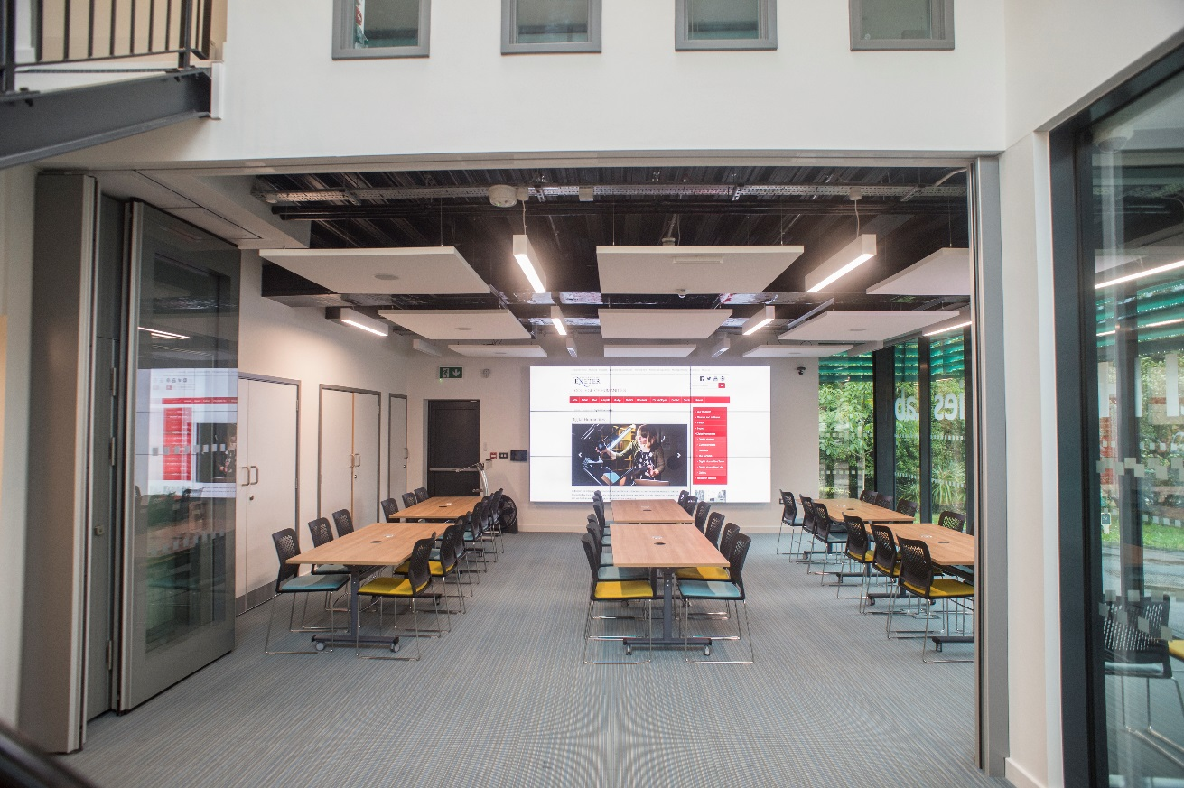

Digital Humanities Lab Seminar room 1
  - Full terms of your booking and our services
We welcome bookings from senior members of the university, academic staff, professional services colleagues and postgraduate students; external organisations and partners are also welcome to contact us for a quote to use our space and facilities.
Each booking that includes video capture running on our video wall and/or high definition streaming must be tested in advance of use. Please add a note to this effect in advance with your booking request.

Ahead of your Digital Humanities Lab booking a technician will:
- Set out the space according to your requirements as stated in your booking request. Please provide us with as much detail as possible about your use of the room and the technology you require in order to support you
- Assist you to connect your devices (such as laptops you wish to project to the video wall) and provide introductory instructions for use of the equipment provided
- Set up the Seminar room PC and ensure any content provided is open, ready for use. Please send us your files at least a day in advance – you can use OneDrive for Office documents, or a web service called WeTransfer for larger files such as images or videos
- Demonstrate use of the wireless keyboard to navigate the settings and menus, and the video wall control panel for adjusting settings such as selecting the input device to display
- Adjust the text size settings for the screen as per your requirements
- Set up any loan equipment you are using for you. We loan:
  - Full size Flipchart/whiteboard and pad (although we recommend using digital versions to utilise the screen and to reduce environmental impact of the use of paper);
  - Seminar room support packs (including a flipchart/whiteboard pens, cleaning wipes, memory sticks and remote controlled pointers);
  - A small collection of DSLR cameras;
  - Digital point and shoot cameras;
  - HDMI cables;
  - Virtual Reality viewers;
  - High quality video cameras;
  - Portable lighting;
  - Microphones;
  - Memory/SD cards.
Items used as part of your booking will be loaned to you and it is your responsibility to return any equipment you take away with you. If the item is not returned within 7 days of your overdue reminder, we will charge you for a replacement.

When you arrive at the Digital Humanities Lab
Please check in with a member of the team at the advisory desk, allowing twenty minutes ahead of the arrival of your attendees to check in, receive support and ask any questions you might have ahead of the booking with us privately.
Our team are available at the advisory desk to support with any technical issues during your booking. We support as far as possible with use of our equipment and systems. Faults on personal equipment and corrupted files are not our responsibility, but we will help you to find an effective workaround as best we can.

Facilities
Our seminar room seats 36 attendees at six rectangular tables, remote controlled blinds and air conditioning have been installed; 4 additional chairs are supplementary to the room for speakers or guests. The seminar room measures 54.98m².
Please note that although we do permit covered beverages such as take away coffee cups or flasks with lids, but we do not allow food due to the damage spillages could cause our high value equipment. Our breakout space is available to book, which includes informal seating. Additional tables can be provided for the serving of catering required.
The nearest toilet facilities are situated in Queen’s building café. Exit the Lab, turn right, climb the green staircase, and then turn left. The café is located through the double doors and to the right. The Digital Humanities Lab provides accessible entry for users with disabilities at the front doors, and the Lab is on one level – however, as we are located off the basement, the nearest disabled toilet is accessible by circling the building to the right until you reach Queen’s building reception. From the reception a disabled toilet is available in Queen’s Café.
We are unable to provide video-conferencing facilities within the room set up. If you would like to host a webinar it will be equipped using a laptop and boundary microphone. We appreciate that this may not suit larger meetings and there are other rooms available on campus that can offer this service. We hope to install video conferencing in the future and we will update our webpage to this effect when available.
Dogs (except guide dogs on leads) are not permitted in the Digital Humanities Lab due to the high value electronic equipment we have installed. Please take care with our electrical equipment and ensure that your drinks are covered by a lid or stored in a portable flask.

Space specifications and advice
The supported space layouts available on request are as follows:
- Workshop style (six rectangular tables positioned vertically in the space connected to power, network and with HDMI cables for device connectivity, our standard set up)
Suited to workshops and seminars where interactivity is the predominant focus of the use of the space; this layout seats 36 people, with 4 additional chairs for speakers.
- Cabaret style (six rectangular tables in three rows of two with power on selected tables)
Suited to talks and presentations where interactivity is minimal, participants are viewing the screen and the focus is on the facilitator; this layout seats 20 people, with additional chairs for speakers.
- Theatre style (our tables are removed and stowed away, the glass partition is opened)
Suited to talks and formal briefings for larger audiences, participants are viewing the screen and the focus is on the speaker; this layout seats a maximum of 60 people.
- Round table style (six tables moved into a horseshoe formation to facilitate open discussion, with power on selected tables); this layout seats 18 people with additional chairs for speakers
Suited to conference and symposia events where discussion is facilitated by digital content on display using our video wall.
- Exhibition style (Tables are removed and stowed away)
Suited to exhibitions, receptions and launches, a lectern is available and staging can be provided by request in advance.

The Digital Humanities team will prepare the room on your behalf, and you will not be required to make arrangements for the Porterage team to set up the room. Please specify your preferred layout and any special requests at the time of booking.

Why am I unable to book the Seminar room?
Seminar room bookings are allocated according to College guidelines. We prioritise the use of the facilities according to funded academic research and projects employing digital methods within the College of Humanities. We also work with other Colleges and external partners where availability allows us flexibility to do so.
Due to the popularity of our spaces and advance bookings we will sometimes be unable to help you with your request. We consider each request carefully and we will always do our best to accommodate you where possible.
There will be periods when the video wall is taken out of action for essential maintenance, testing and for updates to be installed in order to ensure its function. The room will be unavailable for use during these times and where possible we will notify you in advance.

Queries
If you have any queries regarding making a booking with us please email digitalhumanities@exeter.ac.uk or call the Digital Humanities Advisory desk on +44 (0) 1392 72 2500.

