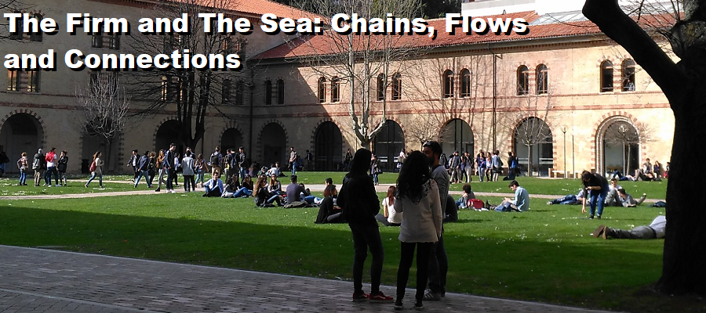

European Business History Association

22nd Annual Congress 6-8 September 2018 - Ancona

Session F3, Room T32: Trade, Markets and Maritime Insurance
Chair: Amedeo Lepore
Antonio Iodice (University of Exeter), Luisa Piccinno (University of Genova)
Investments, Risks and Accidents in Seaborne Trade: General Average as an instrument of mutual protection (17th-18th Centuries)
Giancarlo Ragozini (University of Naples "Federico II"), Maria Carmela Schisani (University of Naples "Federico II"), Maria Prosperina Vitale (University of Naples "Federico II")
The Marine Insurance Industry in Naples over the Italian Unification (1830-1890). A Network Analysis Approach
Harald Espeli (BI Norwegian Business School)
Marine insurance in wartime. The Norwegian Shipowner’s Mutual War Risks Insurance Association during World War I

