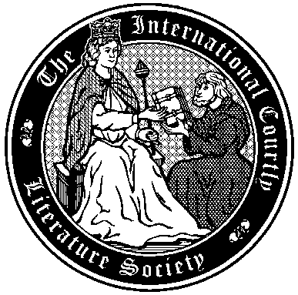
The International Courtly Literature Society

British Branch Conference
Exeter, 14-15 April 2014

NB. Unless specified, all activities will take place in Queen’s Building, Margaret Rooms 1
Monday 14th April
10:15-11:00 | Registration and coffee
11:00-12:30 | Ralph Moffat (Glasgow Museums), ‘A Courtly Emprise? The Combat of the Seven, 1402’  Adrian Stevens (UCL), ‘Ecclesiastical politics and Thomas’s Tristan romance: Gilbert Foliot, Thomas Becket and the trial and ordeal of Isolt’
12:30-13:30 | Buffet lunch
13:30-15:30 | André Penafiel (Oxford), ‘Iberian and Occitan love poetry: reviewing a controversial relationship’  Tom Hinton (Exeter), ‘A man may write of love and not be in love: Authenticity in 13th-century French and Occitan literature’  Ruth Harvey (Royal Holloway), ‘Questions of judgement: women and troubadour song’
15:30-16:00 | Coffee break
16:00-18:00 | Eleanor Hodgson (Sheffield), ‘Girl Power? Women and transformation in Guillaume de Palerne’  Tim Atkin (Cambridge), ‘The Practicalities of Magic in the Roman de Perceforest’  Paola Scarpini (Sheffield), ‘In the shadow of the father: Prothéselaüs’ search for an identity’
18:15-19:00 | Business Meeting (Holland Hall); Conference dinner to follow at 19:30 (Holland Hall)
Tuesday 15th April
09:00-10:30 | Liliana Worth (Oxford), ‘Courtly Aspects of English and Spanish Heroism: A Comparative Study of the Romance of Horn and the Cantar de mio Cid’  Catherine Léglu (Reading), ‘Charlemagne, ‘king of France’ in Occitania: an apparent paradox’
10:30-11:00 | Coffee break
11:00-13:00 | Jessica Stoll (KCL), ‘The Medieval French Lexicon of Translation’  Peter Knowles (Exeter), ‘Grands Rhétoriqueurs and Antoine de Mailly: A reconsideration of the heroic epistles written for Louis XII 1510-13’  Rebecca Dixon (Liverpool), ‘Portraits, Simulacra and Excess in the Burgundian Belle Hélène de Constantinople: Luxury/Luxuria Out of Bounds?’
13:00-14:00 | Buffet lunch
14:00 | Assemble at Queen’s Building Reception to walk into Exeter City Centre for a tour of Exeter Cathedral, Library and Archives where we will see the Exeter Book, among other treasures.  Buses also run regularly from campus into the city centre (D bus).

