NOTAIRES
Notaire 1 : Northerner’s activity in Lebon & Gourdan (number of deeds by Northerners)
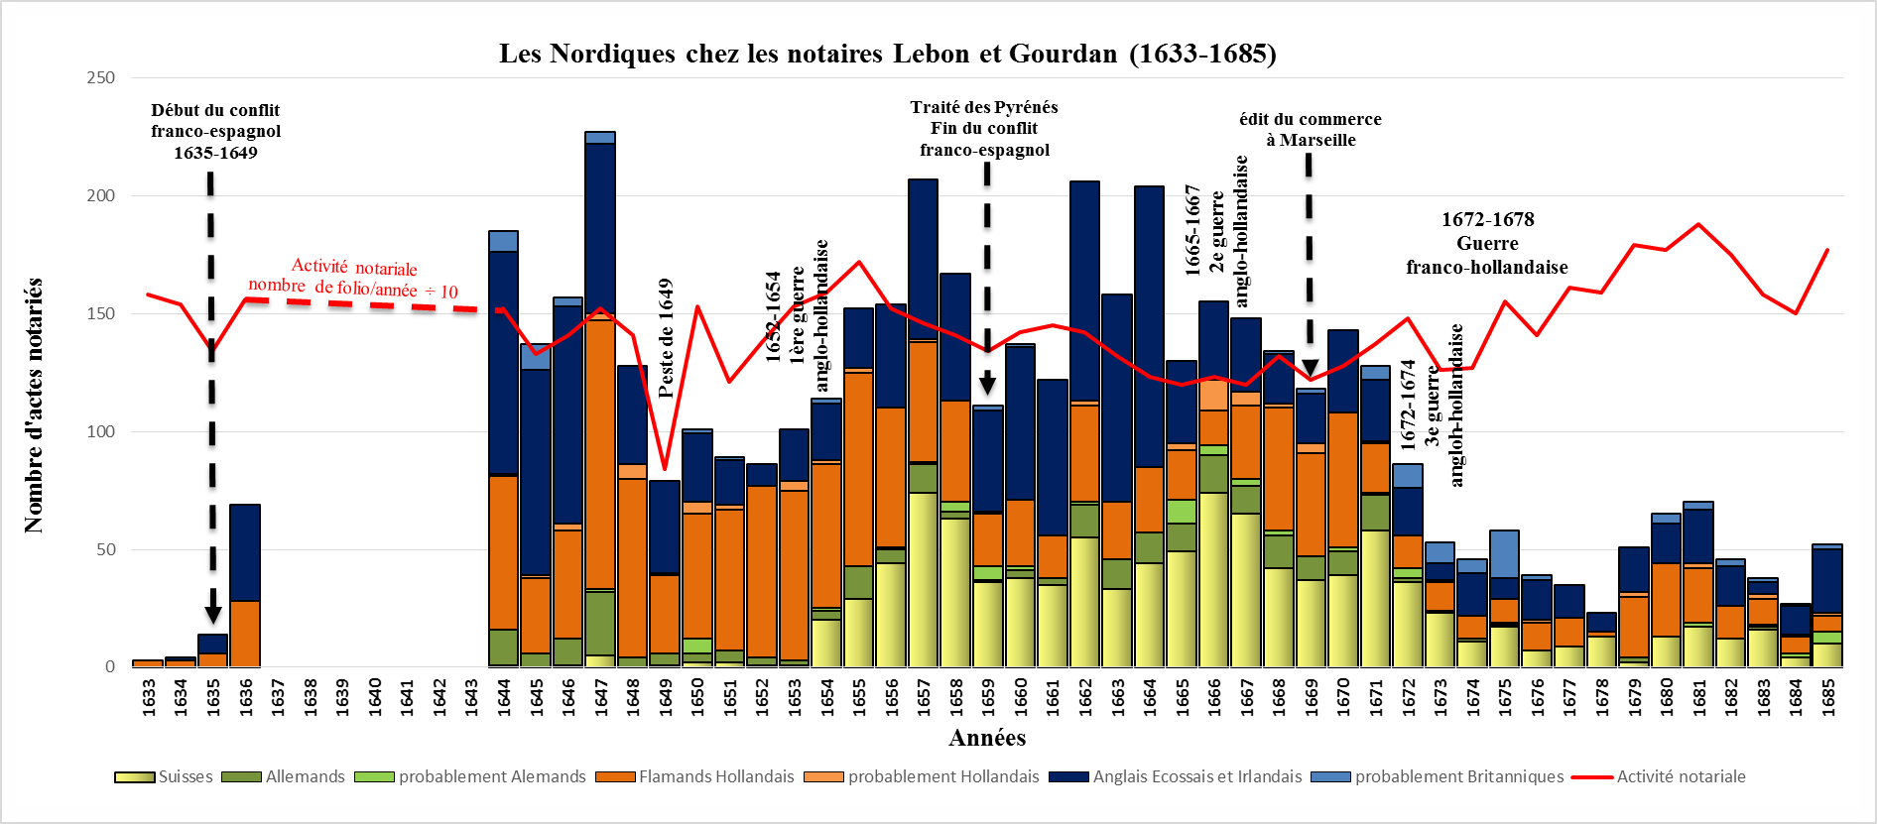

NOTAIRE 2 : Activity of Northerners in Baldoin (number of deeds by Northerners)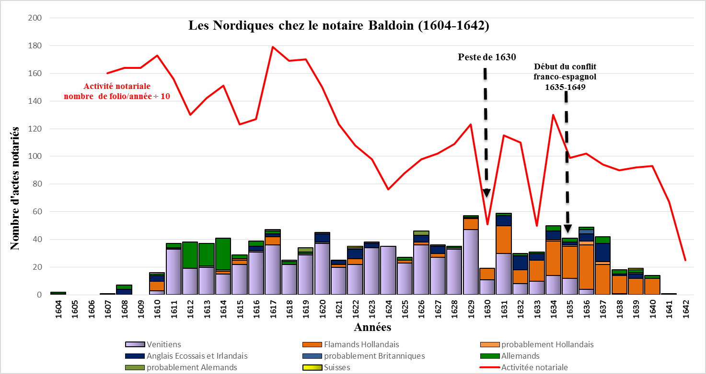

NOTAIRE 3 : Northerner’s activities in Auberge (number of deeds by Northerners)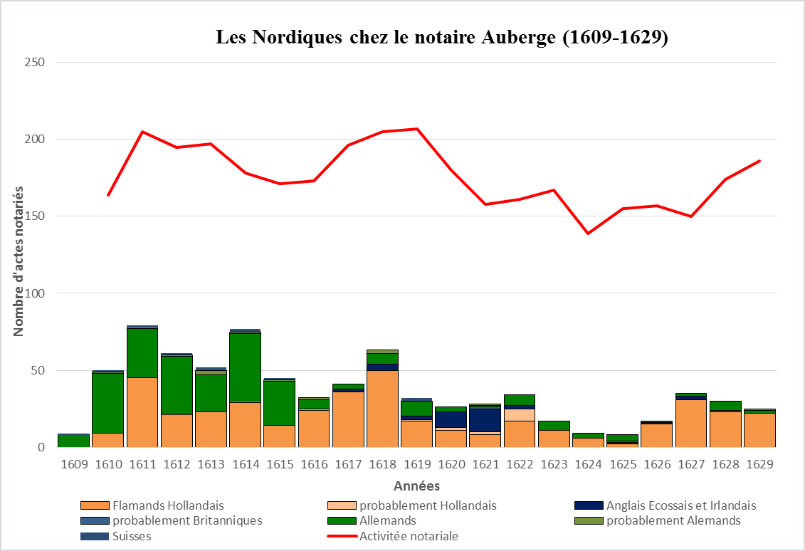

NOTAIRE 4 : Northerners activities cumulated data from 1, 2 & 3 together with Venetian and Swiss merchants
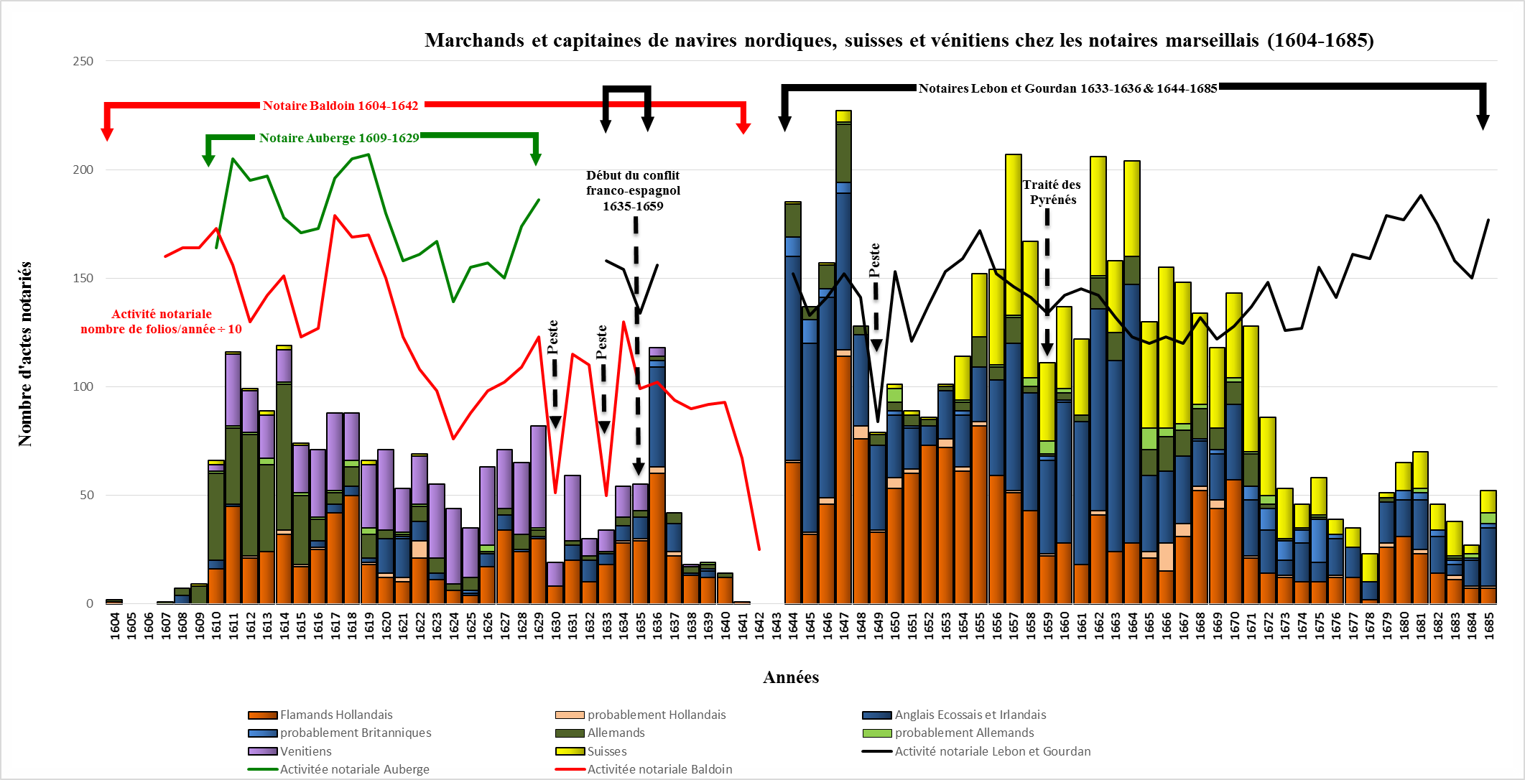

NOTAIRE 5 : Northerners activities cumulated data from 1, 2 & 3 together (without the Venetian and Swiss merchants)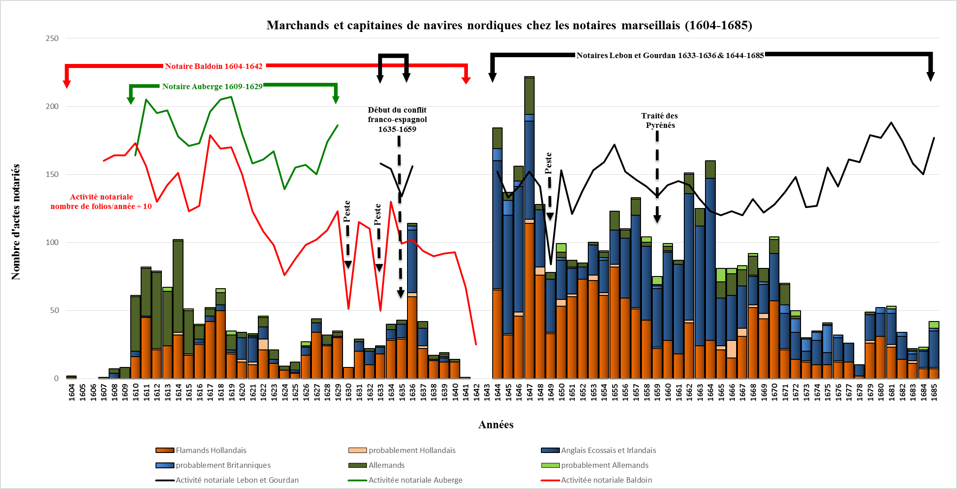

NOTAIRE 6 : Northerner captain’s activities (number of deeds)
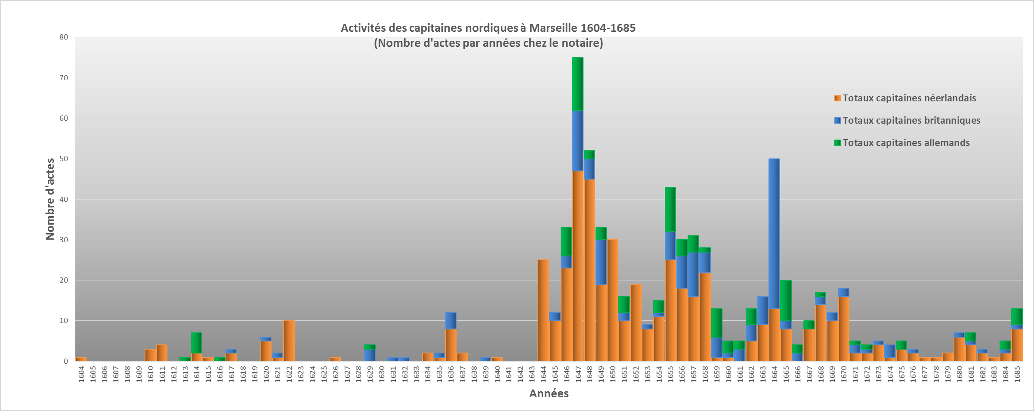

NOTAIRE 7 : Northerner merchant’s activities (number of deeds)

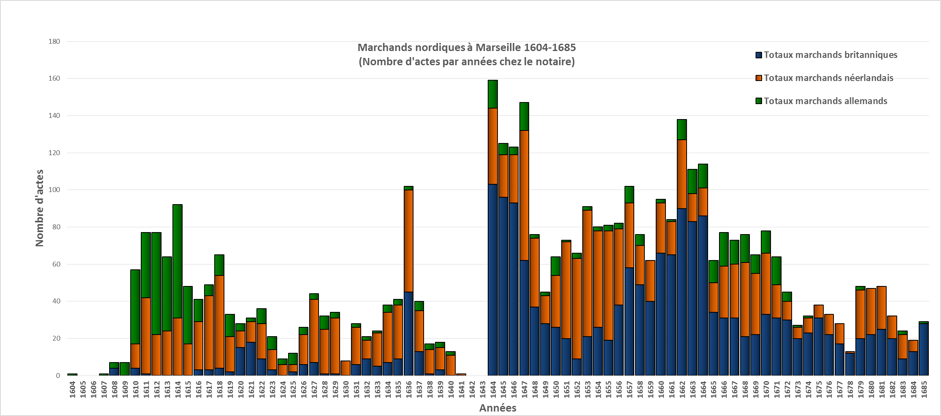

NOTAIRE 8 : Census of Northerners: number of captains and merchants
